(Approx. 886 words)

Taming E-mail
By Dick Maybach, Member, Brookdale Computer User Group, NJ
www.bcug.com
n2nd (at) att.net

Like many others, I rely on e-mail as my primary means of communication, and almost every day I deal with messages that are important to me. The problem of course is to sort them out from the deluge of those that are not. My e-mail vendor does a good job of removing most spam, but still much of what I do see is unimportant. Today I’ll be discussing strategies to make the important messages more accessible than those that are less so. The implementation details will depend on how you access your mail, in particular whether through a Website of with a client program on your PC.

Back in the communications-by-paper era, common advice to improve your efficiency was to touch documents on your desk only once. That is, deal with them the first time you see them. Today the equivalent advice is to move messages from your e-mail inbox the first time you read them. For most messages this is read-and-delete, but you will probably want to file a few, such as those with purchase receipts. Touch-once is a goal, but for me at least, an unattainable one. However, by working toward it you will be improving your efficiency.

I use the Thunderbird e-mail client program, which has a message filter feature. This scans fields in each incoming message, looking at the sender, subject, body, age, size, etc., and acts according to their contents. Each can be deleted, put in a folder, marked as read, etc. Most e-mail clients and Webmail sites have similar tools.

If you correspond with only a few, you might classify as spam all messages except those on an OK list, such as your address book. You will probably have to check the spam folder fairly regularly to be sure you don’t miss something important. This strategy wouldn’t work for me is as I run an organization’s Website and sometimes get questions from its members. I do want to see these, even though I may never have communicated with the senders. Instead, I accept all messages except those that meet specific criteria.

I have found that most forwarded messages are unimportant, and many are frivolous. As a result, all messages with subjects beginning “Fwd:” are immediately sent to the FWD folder. I do look here every day or so, because these are often from friends, although almost never do they require a response, and I don’t want pictures of cute animals cluttering my inbox.

There is also an Ads folder, and incoming mail from many merchants immediately goes there. This isn’t spam, as I do deal with the senders and will again, but some send me several messages a week, and I have no need to deal with them immediately. Of course, it takes a while to develop a set of filters. When I get a new ad, I have to decide if this is likely to be frequent enough to make it worthwhile to define a filter. Every day or two, I do scan through the Ads folder in case there is something interesting (there seldom is) and delete everything else.

My ISP does a good job of filtering spam before I see it. Sometimes too good, I occasionally find valuable messages in the Website spam folder.

Most e-mail programs have a feature similar to what Thunderbird calls the message filter. For example, Figure 1 shows the filter to file forwarded messages.

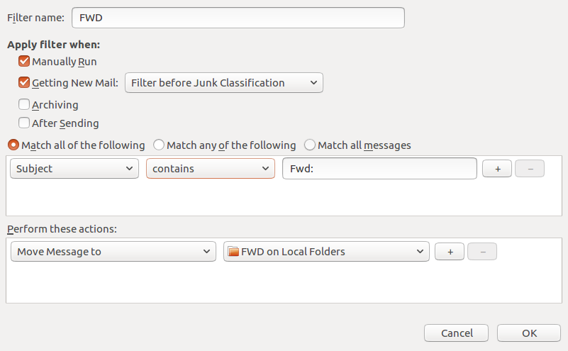
Figure 1. FWD Message Filter.

As you can see, any message whose subject contains “Fwd:” is sent to the local folder FWD. Note that some fields are drop-down lists. For example, Figure 2 shows the alternate choices to these. As a result you have considerable flexibility in setting up your filters.

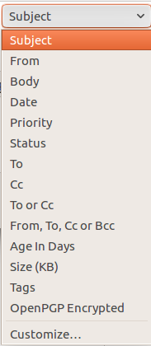 | 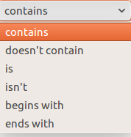 | 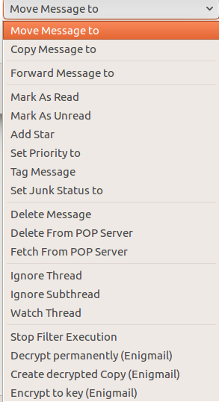
Figure 2. Alternate Choices for Subject, contains, and Move Message to.

Figure 3 shows the AT&T Webmail screen to define an E-mail message filter, which has features similar to Thunderbird’s.

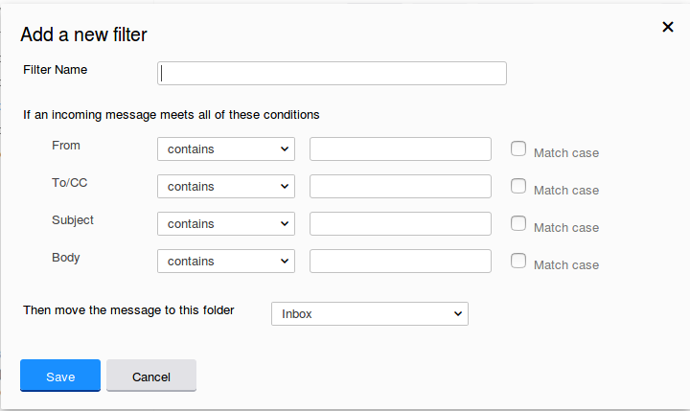
Figure 3. AT&T E-mail Message Filter Definition.

So far, we’ve discussed diverting messages from the inbox, but you probably also want to organize the storage of mail you’ve read but need to retain. For this purpose I’ve created folders to collect those messages, such as BCUG, Finance, Medical, Orders, Personal, and Travel. This makes them easier to locate than if they were somewhere in my inbox.

Every so often, I delete most of the old messages, regardless of in which folder they reside. Once I’ve returned from a trip, I really don’t need its boarding passes, and once an order is delivered, I don’t need its tracking number.

Periodically, check the server, even if you download all your messages to client software on your PC. You may find a valuable message in its spam folder. It’s also a good idea the clear out old messages, as occasionally there are reports of ISP break-ins. You may feel you have nothing to hide, but they probably contain details of your life you don’t want in the wrong hands.

You most likely use e-mail differently than I do, and you probably use different tools to manage it, but you probably also get dozens of messages each day, making it worth taking a little time to develop an appropriate strategy to deal with them efficiently.

